1. 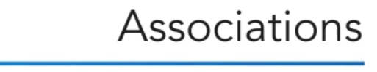
2. After identifying the key classes in our system, we need to represent the relationships among them.
3. 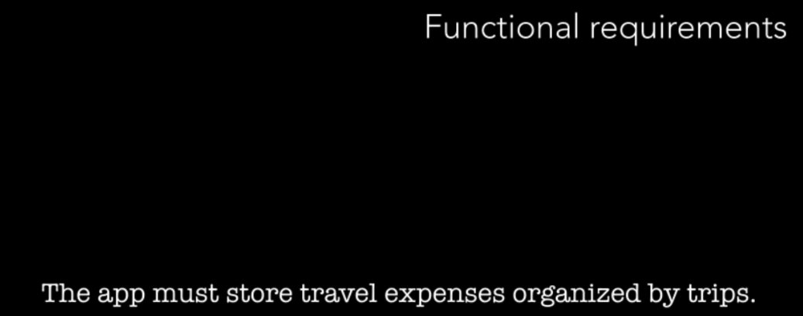
4. Each Trip includes some travel expense.
5. **Line**:
   1. Line b/w classes represents an association.  
      
6. 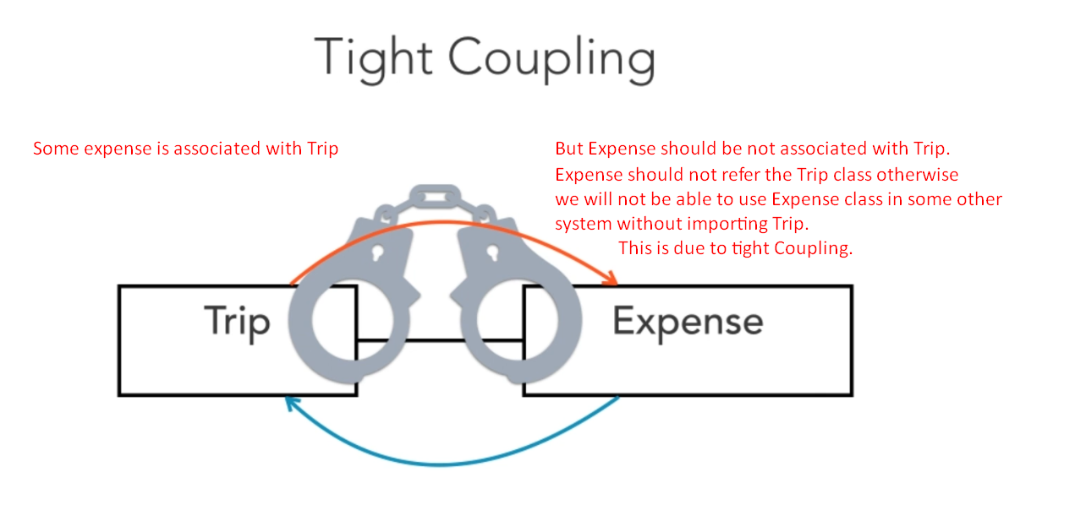
7. UML lets us express **directed associations** by drawing a solid line ending with an open arrowhead.
8. 
9. This arrow represents that only one class refers the other class.
10. 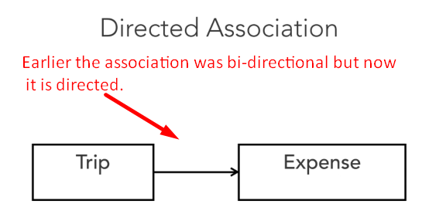
11. A Trip can have multiple expenses.
12. So, we can represent **multiplicity of associated objects** as follow.
13. 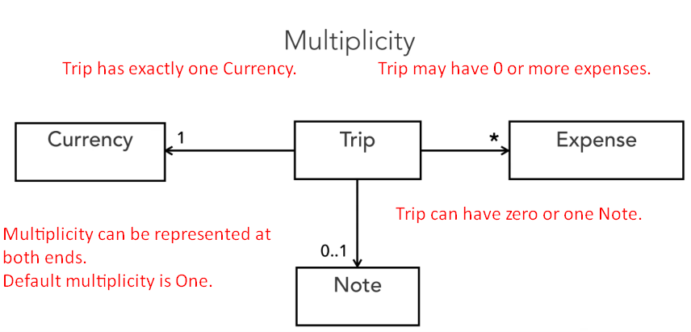
14. 